**PHP: Parsing of messages coming from Basketball Panels and Write into XML**

**Objective:** Write a PHP that receives data from a basketball panel, parses it and writes it into 2 XML files per panel, one only with the last action, the other one with the full event history

**Setup (already tested):** RS-232/RS-422/RS-485 interface from panel is sending information towards an IOT device that converts the RS-xxx messages into HTTP POST request. The relevant HEX data coming from RS-xxx interface is sent as payload of the HTTP POST request the webserver.

**Deliverable:** PHP code to be installed on the LAMP server: Ubuntu, Apache 2.4.18, PHP 7.0.22-0  
to which you will get access

**Droplet Configuration:**

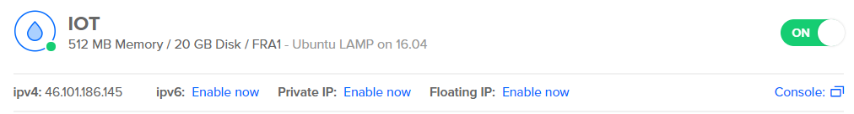

**Logical Scheme:**

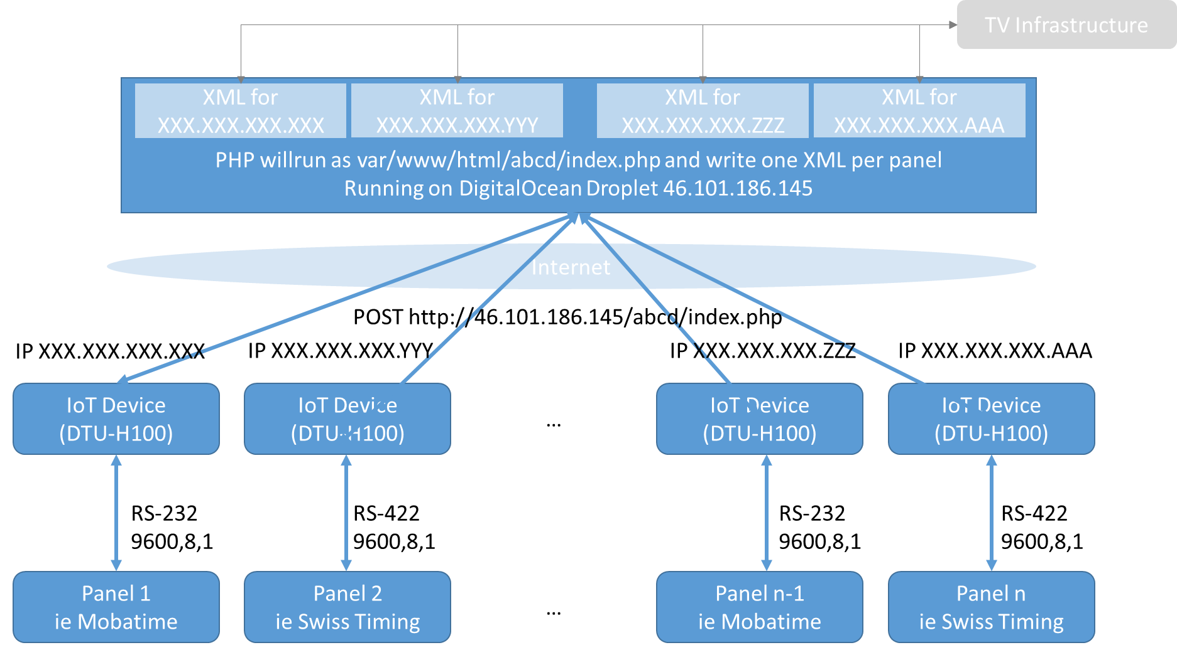

RS-232/RS-422 Input Data coming from panel:

* Panel Type Mobatime (RS-232 9600 Baud): see specifications from Bodet (in attachment)
* Panel Type Swiss Timing (RS-422 9600 Baud): see specifications (in attachment)
* Panel Type Stramatel (RS-485 19200 Baud): see specifications (in attachment)
* Panel Type G+D (RS-232, 19200 Baud): see specifications (in attachment)

PHP used as strawman for now (just writing the payload data into a file)

**Important: As the panels send data between every 100ms (Mobatime) and 1s (G+D/Stramatel), php code needs to be optimised to only make a write into the XML file if there was a change from the last status for the respective panel, otherwise the data should be discarded. CRC (checksum) - if available - to be checked and packets with invalid CRC to be discarded.**

**HTTP Request coming from DTU-H100 to Apache Web Server**

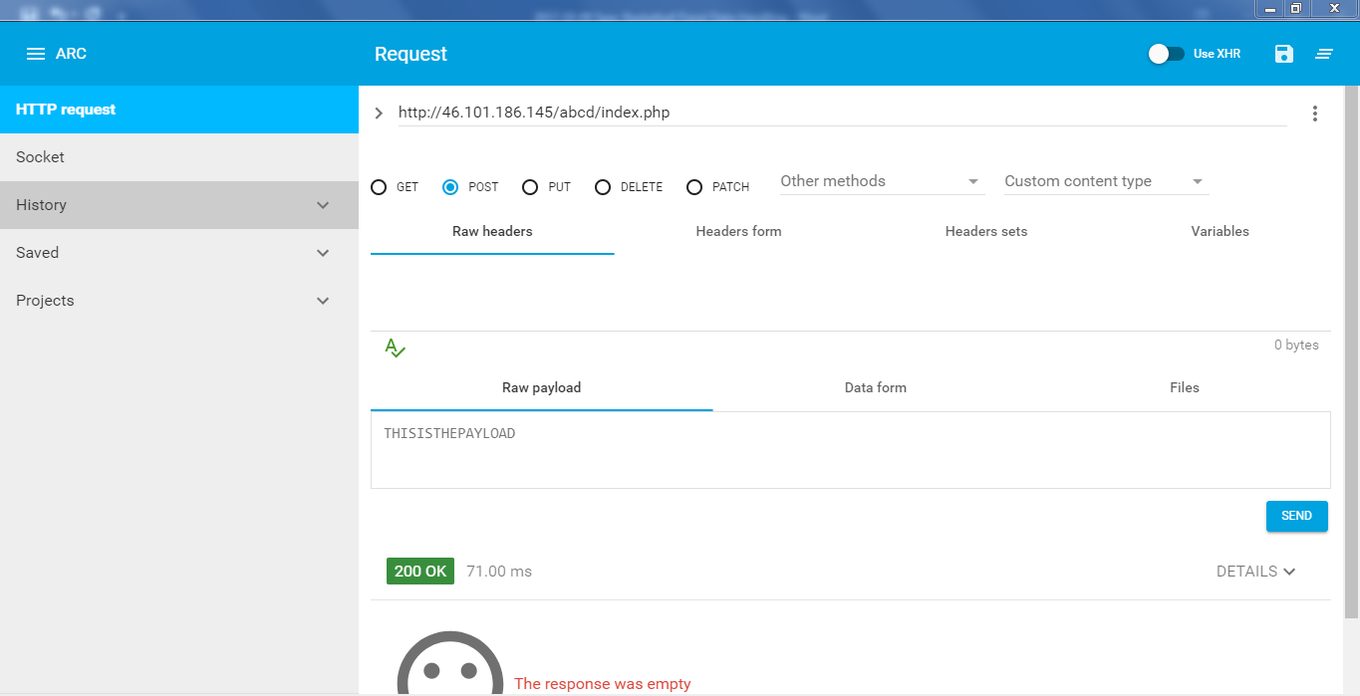

**Current PHP Code on Apache Web Server to test proper reception of request and write log  
(for E2E testing purpose, will be replaced by the software you develop)**

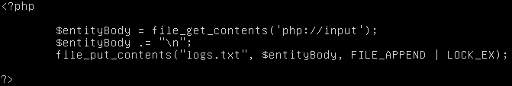

**Output XML Data (last action), for definitions of data structure, see Appendix 1 - 4**

|  |  |  |  |  |  |
| --- | --- | --- | --- | --- | --- |
|  | SwissTiming (Chapter – Byte) | Mobatime/Bodet (Message – Byte) | Stramatel (Position in 54 byte statement) | G+D (Position in 3x60 char statement) | |
| <document> | - | - | - | - | |
| <event> | - | - | - | - | |
| <TeamA>BONCOURT</TeamA> | 4.1 – 3 | n/a, write LOCAL | n/a, write LOCAL | n/a, write LOCAL | |
| <TeamB>MONTHEY</TeamB> | 4.1 – 15 | n/a, write VISITOR | n/a, write VISITOR | n/a, write VISITOR | |
| <ScoreTeamA>86</ScoreTeamA> | 3.2 – 8 | 30 – 4 to 6 | 9-11 | Data1/1-3 | |
| <ScoreTeamB>66</ScoreTeamB> | 3.2 - 11 | 30 – 7 to 9 | 12-14 | Data1/4-6 | |
| <TeamFoulA>4</TeamFoulA> | 3.2 – 14 | 31 – 5 | 16 | Data1/7-8 | |
| <TeamFoulB>4</TeamFoulB> | 3.2 – 15 | 31 – 7 | 17 | Data1/12-13 | |
| <TimeOutA>4</TimeOutA> | 3.2 – 16 | 18 – 9 | 18 | n/a | |
| <TimeOutB>4</TimeOutB> | 3.2 – 17 | 18 – 10 | 19 | n/a | |
| <Quarter>Q4</Quarter> | 3.2 – 18 | 18 – 13 | 15 | Data1/10 | |
| <StartStop>START</StartStop> | 3.2 – 20 | 18 – 3b1 | 21 | Calculated? | |
| <Timeout>Yes</Timeout> | 3.2 – 22 | 19 – 4 and 5 | 22 | Calculated? | |
| <ClockTime>00:00</ClockTime> | 3.2 – 3 | 18 – 5 to 8 | 5-8 | Data1/15-19 | |
| <ClockTimeOut>00</ClockTimeOut> | 3.2 – 22 | 19 – 6 and 7 | 22,47-48 |  |
| <ShotClock>00</ShotClock> | 3.2 - 24 | 50 – 4 and 5 | 53 |  |
| <UTCTime>2017-09-21 21:14:57</UTCTime> | 3.9 – calculated | 20 – calculated (taking date from server) | n/a – calculated (taking date from server) | n/a – calculated (taking date from server) | |
| </event> | - | - | - | - | |
| </document> | - | - | - | - | |

**Output XML Data (history), for definitions of data structure, see Appendix 1 - 4**

|  |  |  |  |  |
| --- | --- | --- | --- | --- |
|  | SwissTiming | Mobatime/Bodet | Stramatel | G+D |
| <document> | - |  |  |  |
| <playerinfo> | - | - | - | - |
| <PlayerinfoA=NumberOfPlayers> | Calculated | Calculated | Calculated | Calculated |
| <ShirtNo>XX</ShirtNo><Points>XX</Points><Fouls>XX</Fouls> | 3.3 and 3.5 | 37, 58 – 4 to 8, 33 – 4 to 15 | ShirtNo n/a, Points n/a, 23 | Data2/1-2, Data2/4-5, Data2/3 |
| … | - |  |  |  |
| <ShirtNo>XX</ShirtNo><Points>XX</Points><Fouls>XX</Fouls> | 3.3 and 3.5 | 37, 58 – 4 to 8, 33 – 4 to 15 | No shirts, no points, 34 | Data2/56-57, Data2/59-60, Data2/58 |
| </PlayerinfoA> | - |  |  |  |
| <PlayerinfoB=NumberOfPlayers> | Calculated | Calculated | Calculated | Calculated |
| <ShirtNo>XX</ShirtNo><Points>XX</Points><Fouls>XX</Fouls> | 3.4 and 3.6 | 38, 58 – 4 to 8, 33 – 4 to 15 | No shirts, no points, 35 | Data3/1-2, Data3/4-5, Data3/3 |
| … | - |  |  |  |
| <ShirtNo>XX</ShirtNo><Points>XX</Points><Fouls>XX</Fouls> | 3.4 and 3.6 | 38, 58 – 4 to 8, 33 – 4 to 15 | No shirts, no points, 46 | Data3/56-57, Data3/59-60, Data3/58 |
| </PlayerinfoB> | - | - | - | - |
| </playerinfo> | - | - | - | - |

(continued)

|  |  |  |  |  |
| --- | --- | --- | --- | --- |
| <playbyplay> | - | - | - | - |
| <event> | - | - | - | - |
| <TeamA>BONCOURT</TeamA> | 4.1 – 3 | n/a, write LOCAL | n/a, write LOCAL | n/a, write LOCAL |
| <TeamB>MONTHEY</TeamB> | 4.1 – 15 | n/a, write VISITOR | n/a, write VISITOR | n/a, write VISITOR |
| <ScoreTeamA>86</ScoreTeamA> | 3.2 – 8 | 30 – 4 to 6 | 9-11 | 1-3 |
| <ScoreTeamB>66</ScoreTeamB> | 3.2 - 11 | 30 – 7 to 9 | 12-14 | 4-6 |
| <TeamFoulA>4</TeamFoulA> | 3.2 – 14 | 31 – 5 | 16 | 7-8 |
| <TeamFoulB>4</TeamFoulB> | 3.2 – 15 | 31 – 7 | 17 | 12-13 |
| <TimeOutA>4</TimeOutA> | 3.2 – 16 | 18 – 9 | 18 | n/a |
| <TimeOutB>4</TimeOutB> | 3.2 – 17 | 18 – 10 | 19 | n/a |
| <Quarter>Q4</Quarter> | 3.2 – 18 | 18 – 13 | 15 | 10 |
| <StartStop>START</StartStop> | 3.2 – 20 | 18 – 3b1 | 21 | Calculated? |
| <Timeout>Yes</Timeout> | 3.2 – 22 | 19 – 4 and 5 | 22 | Calculated? |
| <ClockTime>00:00</ClockTime> | 3.2 – 3 | 18 – 5 to 8 | 5-8 | 15-19 |
| <ClockTimeOut>00</ClockTimeOut> | 3.2 – 22 | 19 – 6 and 7 | 22,47-48 |  |
| <ShotClock>00</ShotClock> | 3.2 - 24 | 50 – 4 and 5 | 53 |  |
| <UTCTime>2017-09-21 21:14:57</UTCTime> | 3.9 – calculated | 20 – calculated (taking date from server) | 20 – calculated (taking date from server) | 20 – calculated (taking date from server) |
| </event> | - | - | - | - |
| … | - | - | - | - |
| <event> | - | - | - | - |
| As above | - | - | - | - |
| </event> | - | - | - | - |
| </playbyplay> | - | - | - | - |
| </document> | - | - | - | - |

**Appendix1: Documentation from SwissTiming**

** **

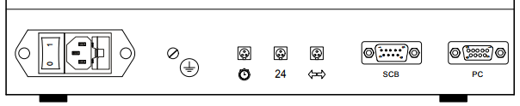

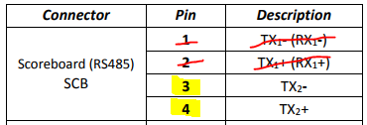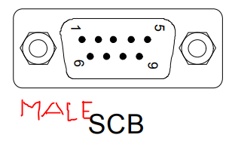

** **

<https://www.mouser.ch/ProductDetail/Amphenol-Tuchel/C016-30H006-100-10/?qs=sGAEpiMZZMvG94qpybaIZUbMDiDcULcBqJT0ZjJ9mHY%3d>

<https://www.mouser.ch/ProductDetail/Amphenol-Tuchel/C016-30D006-100-10/?qs=sGAEpiMZZMvG94qpybaIZUbMDiDcULcBY3rMQk%2f%2fEWE%3d>

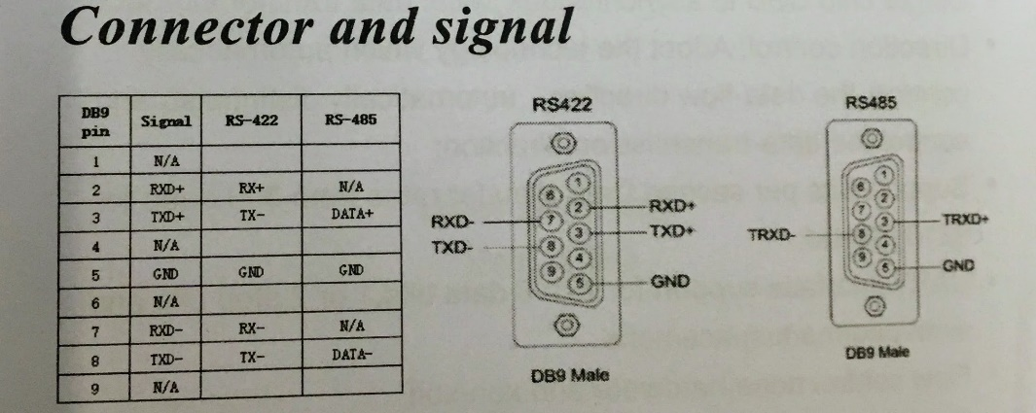

**Appendix2: Documentation Bodet/Mobatime**



**Appendix3: Documentation Stramatel (incl. Cable Manufacturing)**



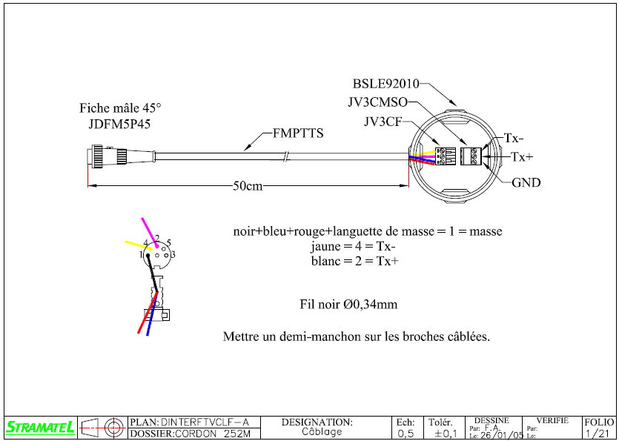

Wikipedia: A common de-facto standard is the use of: TX+/RX+ or D+ as alternative for B (high for MARK i.e. idle); TX-/RX- or D- as alternative for A (low for MARK i.e. idle)

**Appendix4: Documentation G+D**

